SPRING TIMETABLE -

BLOCK 1 |  |  |  | BLOCK 2 |  |  |  | BLOCK 3
12/12/25 | 09/01 | 16/01 | 23/01 | 30/01 | 06/02 | 13/02 | 27/02 | 06/03 | 13/03 | 20/03 | 27/03
YEAR 3 | YEAR 4 | YEAR 5 | YEAR 6 | YEAR 3 | YEAR 4 | YEAR 5 | YEAR 6 | YEAR 3 | YEAR 4 | YEAR 5 | YEAR 6
NURSERY | RECEPTION | YEAR ONE | YEAR TWO | NURSER | REC. | YEAR 1 | YEAR 2 | NURSERY | RECEPTION | YEAR 1 | YEAR 2

PROGRESSION MAP - SPRING
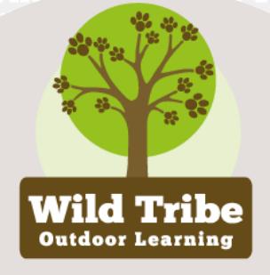 | BLOCK 1 | BLOCK 2 | BLOCK 3
NURSERY | Making Rope | School map and compass points | Story stone trail (book week)
RECPTION | Basic knots | Map symbols and finding North | Teddies teepee
YEAR 1 | Paracord bracelets | Draw a map - home to school | Seed bombs
YEAR 2 | Paracord keyrings | Compass and 8 compass points | Spring crafts
YEAR 3 | Paracord, knotboards | Using bearings to navigate | Story stone trail (book week)
YEAR 4 | Paracord, knotboards | Grid references and treasure hunt | Bug hotels
YEAR 5 | Paracord bracelets | Bearings to create routecards | Tree faces (clay)
YEAR 6 | Paracord bottle carrier | Route cards and trails | Woodland bathing, shelter building

