Class Reader Plans
We read to children every day. We choose these books carefully as we want children to experience a wide range of books that open windows into other worlds and cultures.
Teachers read the following core texts and other choices of text from the Doug Lemov Reading spine or those they are passionate about (but are not contained in another year group’s spine or teaching sequence).
Non fiction texts are placed in the Autumn term, for all classes to read in November, during Non fiction November. Where possible they are matched to topic or curriculum areas. Teachers additionally, select non- fiction texts linked to the interest of the cohort.
A poem anthology is included in each year group.
Focus authors are mapped out for each year group to help develop children's author knowledge. Some of the texts link to our whole class teaching curriculum.
This plan is evaluated and updated yearly. Key = cultural capital

 | Autumn 1st half | Autumn 2nd half  Non fiction November | Spring 1st half  Whole school author visit/ world book day event | Spring 2nd half | Summer 1st half | Summer 2nd half
Nursery &  Reception | ‘Our Favourite 5’ each half term as well as topic related books.  Children are involved in voting for our ‘favourite 5’ taken from a selection of classic, high quality texts chosen by the teacher.
Year 1 | 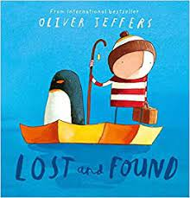  Lost and Found- Oliver Jeffers * author focus  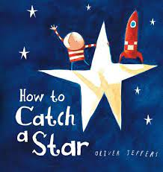  How to catch a star - Oliver Jeffers  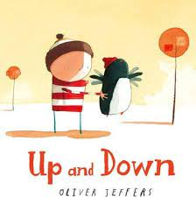  Up and Down - Oliver Jeffers  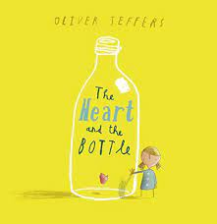  The Heart and the bottle - Oliver Jeffers  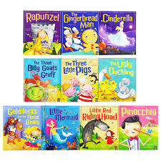  Traditional Tales/Fairy Tales | 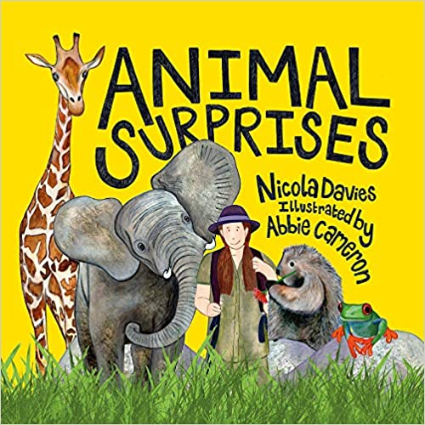  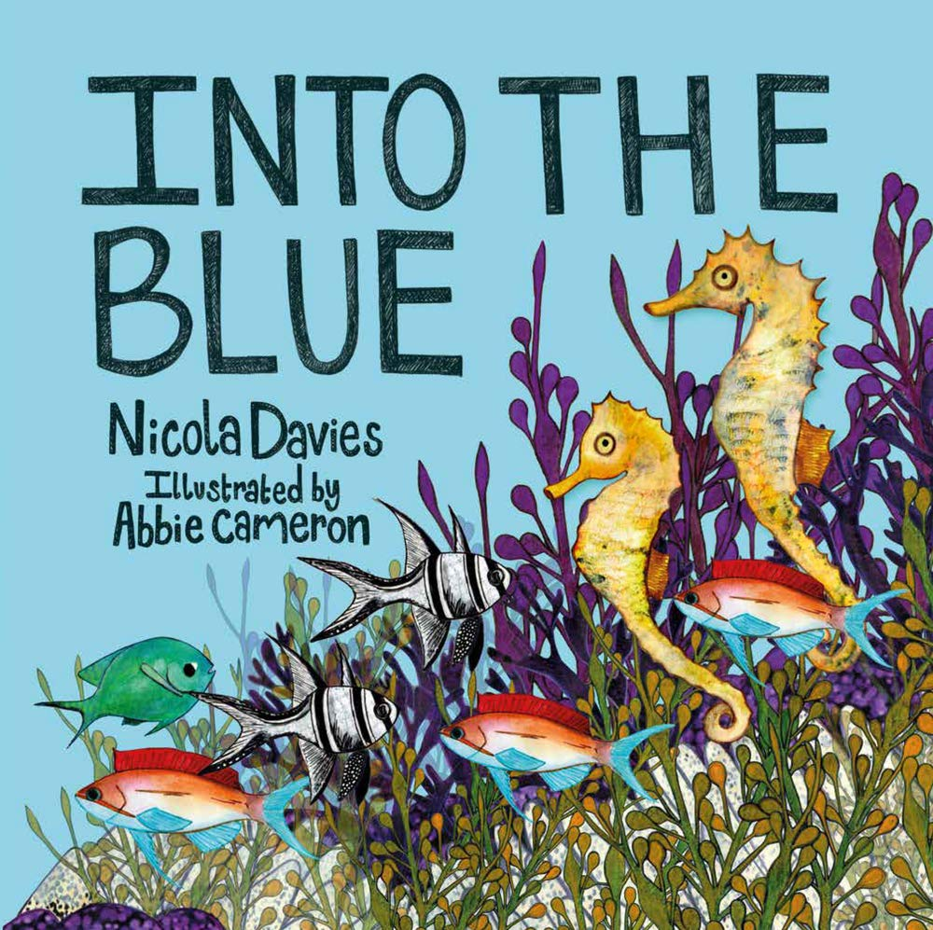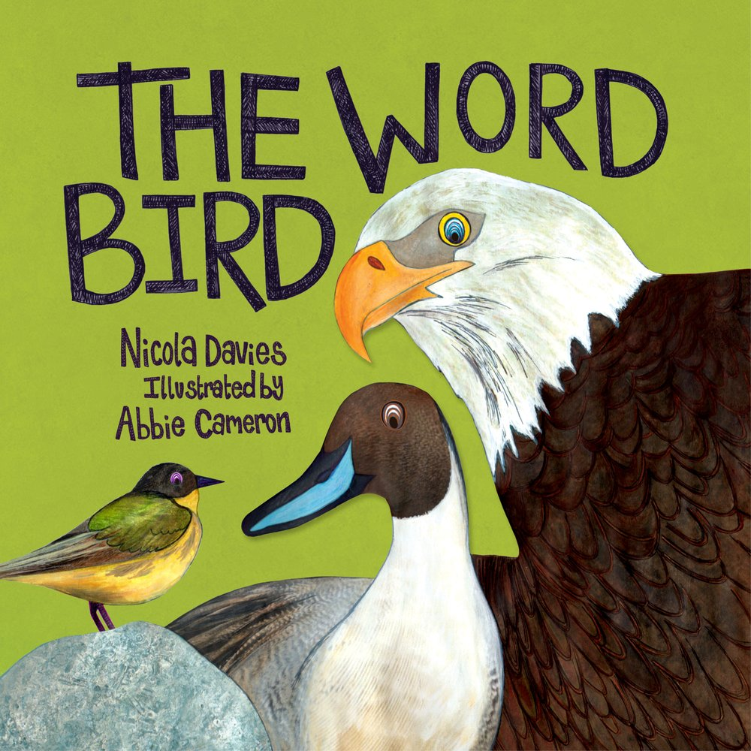  Animal Surprises, Into the Blue and The Word Bird - Nicola Davies *non-fiction november  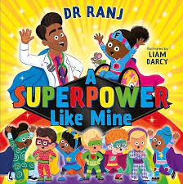  A superpower like mine - Dr Ranj | 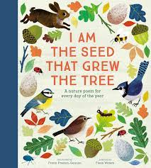  I Am the Seed That Grew the Tree: A Nature Poem for Every Day of the Year  Fiona Waters & Frann Preston-Gannon  Poem Anthology  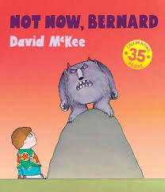  Not Now Bernard-David Mckee  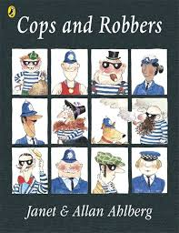  Cops and Robbers - Allan Ahlberg  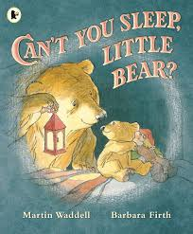  Can’t You Sleep Little Bear? - Martin Waddell | 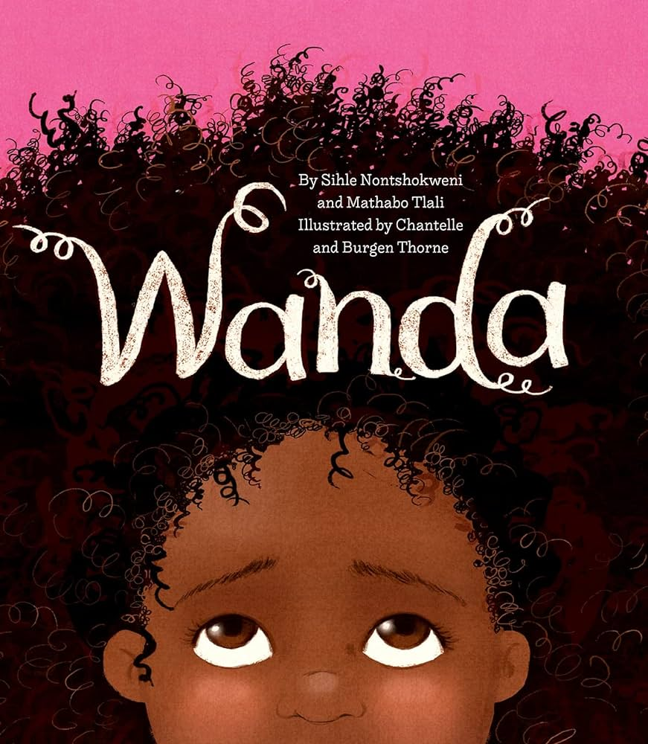  Wanda - Sihle Nontshokweni  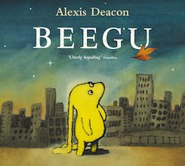  Beegu - Alex Deacon  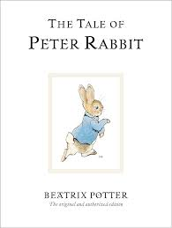  The Tale of Peter Rabbit | 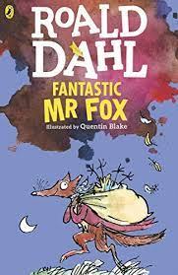  Fantastic Mr Fox - Roald Dahl | 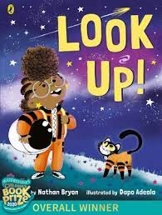  Look Up!-Nathan Bryan *author focus  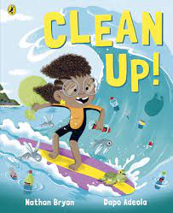  Clean Up! - Nathan Bryan  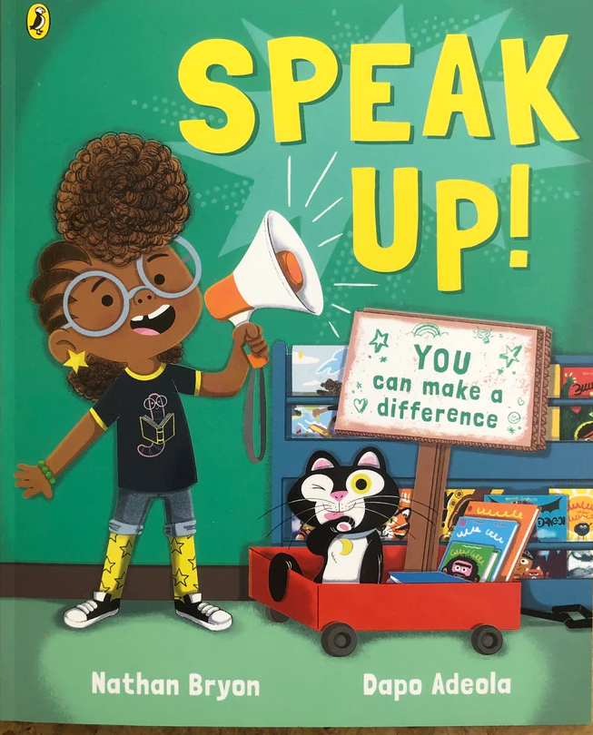  Speak Up! - Nathan Bryan  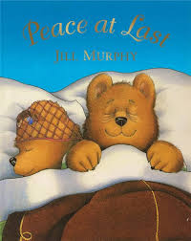  Peace at Last – Jill Murphy
Year 2 | 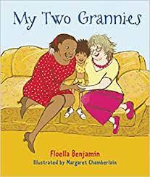  My Two Grannies- Floella Benjamin *author focus  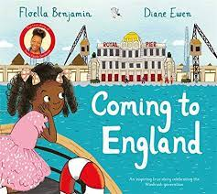  Coming to england- Floella Benjamin  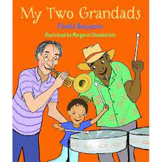  My two Grandads - Floella Benjamin  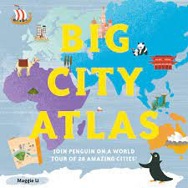  Big City Atlas)- Maggie Li | 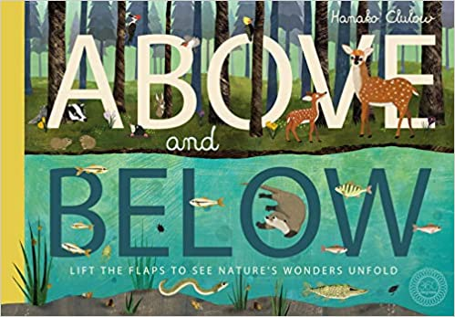  Above and Below - Patricia Hegarty *non-fiction november  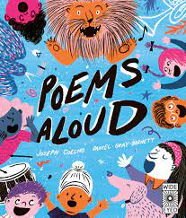Poems Aloud: An anthology of poems to read aloud  Poem Anthology | 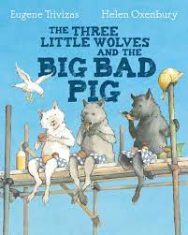  The Three Little Wolves and the Big Bad Pig - Eugene Trivizas  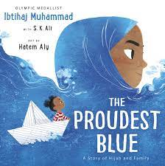  The Proudest Blue- Ibtihaj Mumhammd  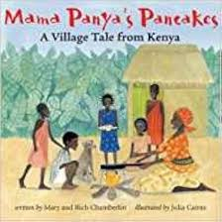Mama Panya’s Pancakes – Mary &  Richard Chamberlain  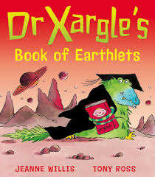  Dr Xargle’s Book of Earthlets - Tony Ross | 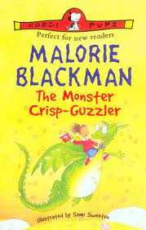  The Monster Crisp-Guzzler Malorie Blackman  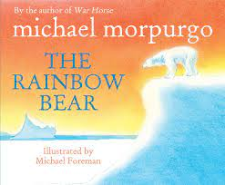  The Rainbow Bear-Michael Morpurgo | 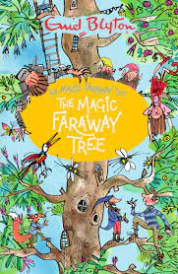  The Magic Faraway Tree- Enid Blyton  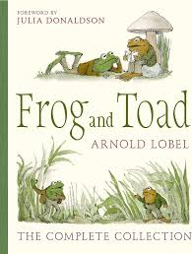  Frog and Toad Novels - Arnold Lobel | 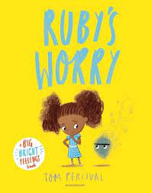  Ruby’s Worry- Tom Percival *author focus  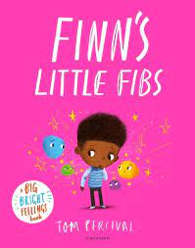  Finn’s Little Fibs - Tom Percival  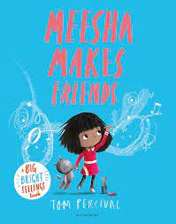  Meesha makes friends - Tom Percevial  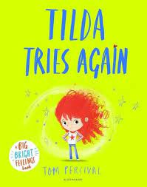  Tilda tries again - Tom Percevial
Year 3 | 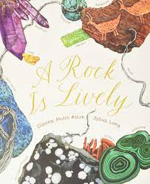  A Rock Is Lively)-Dianna Hutts Aston  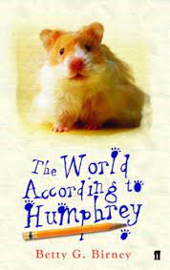  The World According to Humphery-Betty G Birney | 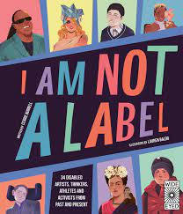  I am Not a Label -Cerrie Burnell *author focus  *non-fiction november  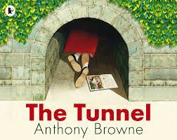  The Tunnel-Anthony Brown | 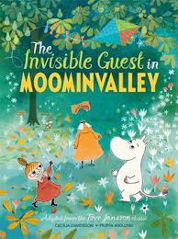  The Invisible Guest in Moominvalley - Tove Jansson | 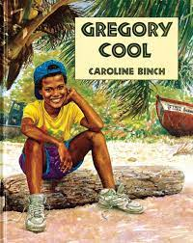  Gregory Cool - Carloine Binch  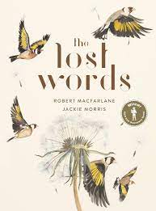  The Lost Words  Robert MacFarlane & Jackie Morris-  Poem Anthology | 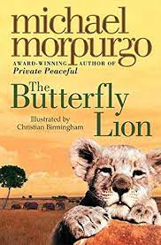  The Butterfly Lion-Michael Morpurgo | 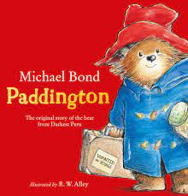  The Original story of the bear from Darkest Peru - Micheal Bond *author focus
Year 4 | 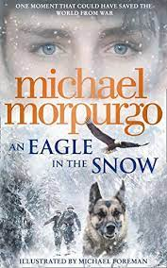  The Eagle in the snow - Michael Morpurgo | 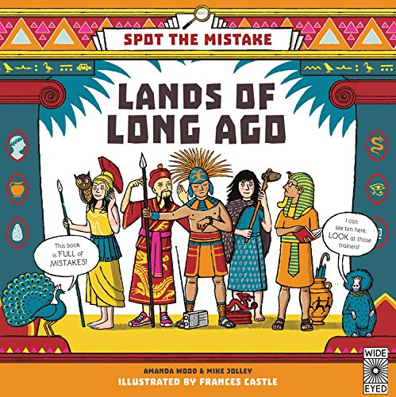Lands of Long Ago - Amanda Wood and Mike Jolley *non-fiction november  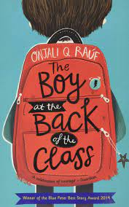  The Boy at the Back of the Class - Onjali Q Rauf | 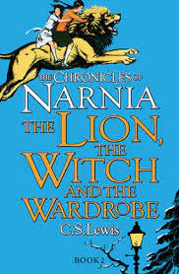  The Lion, The Witch and the Wardrobe - C.S Lewis (linked to whole class reading)  *author focus | 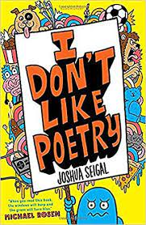  I Don't Like Poetry -  Joshua Seigal | 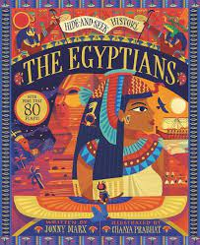The Egyptians - Chaaya Prabhat | 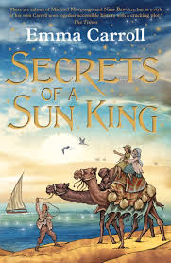  Secrets of the Sun King - Emma Caroll (linked to whole class reading)
Year 5 | 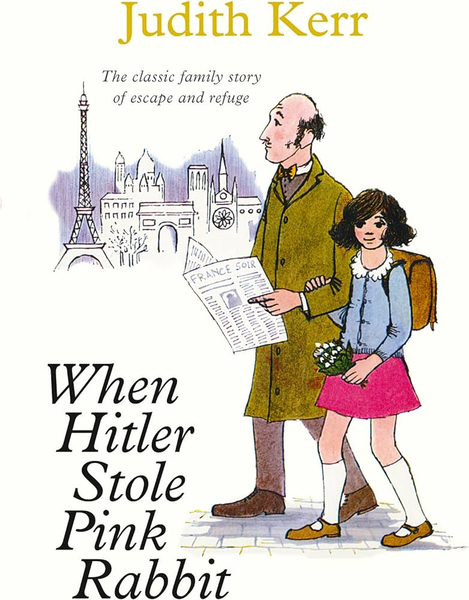  When Hitler stole pink rabbit - Judith Kerr  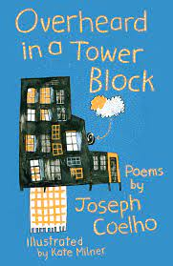  Overheard in a Tower Block  Joseph Coelho & Kate Milner  Poem Anthology | 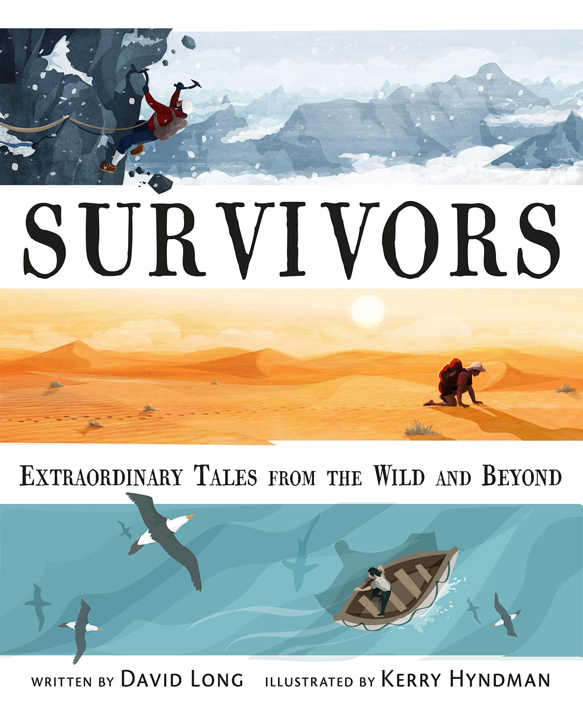Survivors - David Long *non-fiction november  (link to whole class reading)  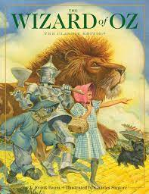  The Wizard of Oz - L Frank Baum | 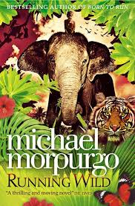  Running Wild - Micheal Morpurgo (link to whole class reading)  *author focus | 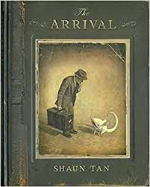  The Arrival - Shaun Tan  *author focus | 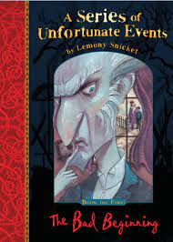  A series of unfortunate events - Lemony Snicket | 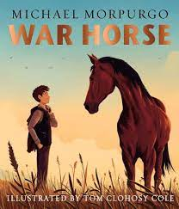  War Horse - Michael Morpurgo
Year 6 | 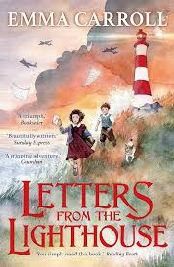  Letters from the Lighthouse (Emma Carroll) (link to whole class reading)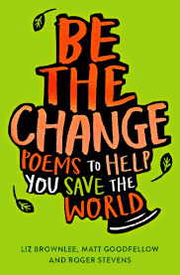  Be The Change: Poems to Help you Save the World  Liz Brownlee, Roger Stevens & Matt Goodfellow  Poem Anthology | 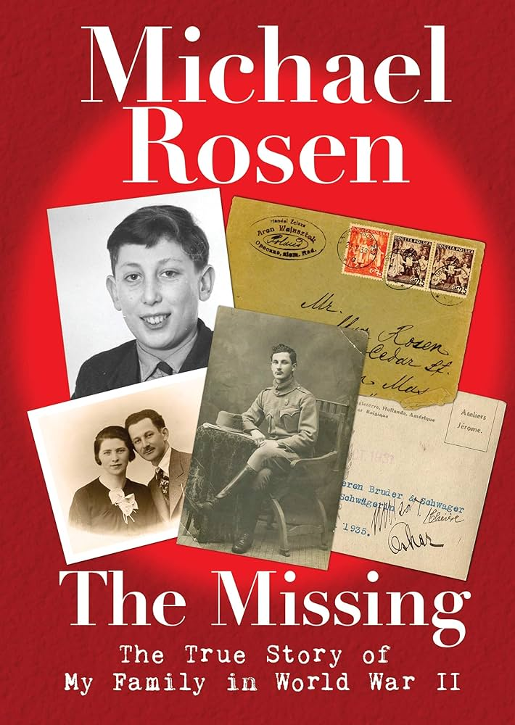  The missing (Micheal Rosen) *non-fiction november  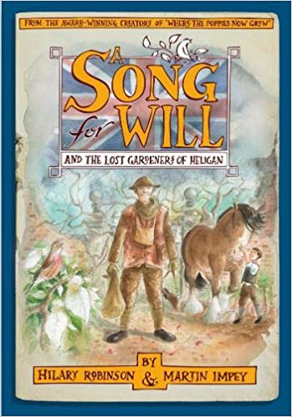  A Song for Will - The Lost Gardens of Heligan - Hilary Robson | 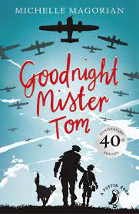  Good Night Mister Tom - Michelle Migorian |  | 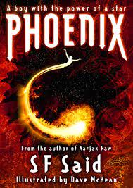  Phoenix- S.F. Said | 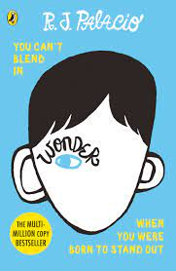  Wonder - R.J.Palacio  *author focus

